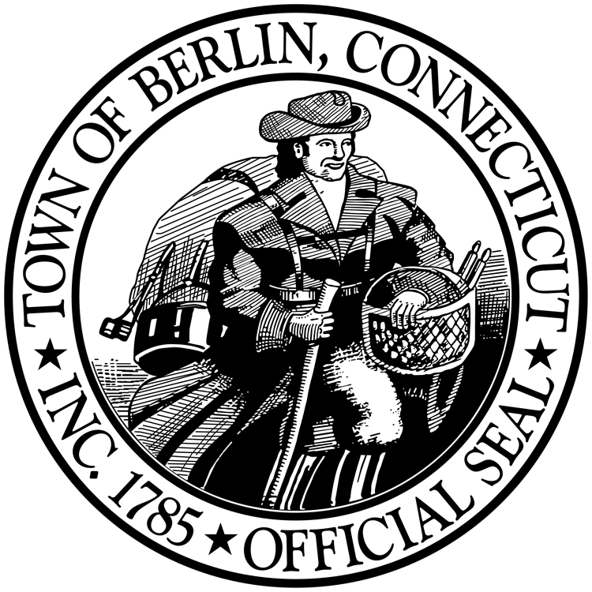
TOWN OF BERLIN
Inland Wetlands
and
Water Courses Commission
240 Kensington Road • Berlin, CT 06037
Office (860) 828-7022 • Fax (860) 828-7180

LEGAL NOTICE

PUBLIC HEARING

TOWN OF BERLIN

INLAND WETLANDS AND WATER COURSES COMMISSION

The Inland Wetlands and Water Courses Commission of the Town of Berlin will hold
a public hearing in the Public Works/Engineering Department (Room 120), 240 Kensington Road, Berlin, CT on Tuesday, May 6, 2025 at 7:00 P.M. to consider the following:

Application 25-03W - Proposal by Vesta Corporation and O'Riordan Migani Architects, LLC to construct an Affordable Elderly Housing Complex with associated improvements, on Lots 63 and 65, Block 54, #143 Percival Avenue.

Application 25-04W - Proposal by Shuttle Meadow Development to construct a three (3) lot subdivision and associated improvements within a Regulated Area on Lot 6A, Block 12F, #398 Chamberlain Highway.

At this meeting, interested persons may be heard and written communications may be received. Copies of the Applications related to this hearing are open for inspection in the office of the Town Engineer in Room 120 of the Town Hall.

Peter Nieman, Chairman
Inland Wetlands and Water Courses Commission

Publish in The New Britain Herald:
April 25, 2025
May 2, 2025

